Schema Migration

🌟 Definition
# Source: AI Source: Provided by: [Data Path: Persons Table -> ID Column: 1, Name_En Column: Motasem Essam] -> From: [ChatGPT] on [6/7/2026]
Schema Migration is the process of changing the structure (schema) of a database without necessarily changing the actual data.
A schema defines how data is organized in a database.
It includes:
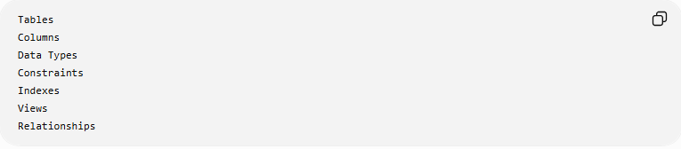
Tables
Columns
Data Types
Constraints
Indexes
Views
Relationships

🎯 Purpose
# Source: AI Source: Provided by: [Data Path: Persons Table -> ID Column: 1, Name_En Column: Motasem Essam] -> From: [ChatGPT] on [6/7/2026]
Schema migrations are used to:
- Add new features
- Modify database structure
- Improve performance
- Enforce business rules
- Support application updates

🧠 Simple Definition
# Source: AI Source: Provided by: [Data Path: Persons Table -> ID Column: 1, Name_En Column: Motasem Essam] -> From: [ChatGPT] on [6/7/2026]
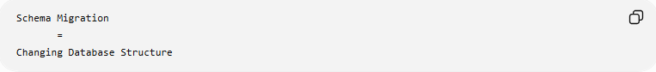
Schema Migration
=
Changing Database Structure

📚 What is a Database Schema?
# Source: AI Source: Provided by: [Data Path: Persons Table -> ID Column: 1, Name_En Column: Motasem Essam] -> From: [ChatGPT] on [6/7/2026]
A schema is the blueprint of a database.
Example:
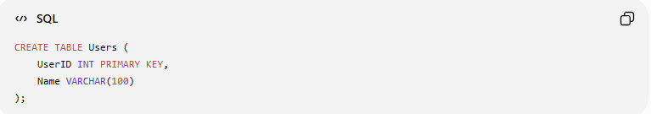
CREATE TABLE Users (
UserID INT PRIMARY KEY,
Name VARCHAR(100)
);
Schema:
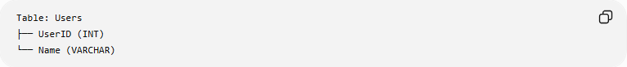
Table: Users
├── UserID (INT)
└── Name (VARCHAR)

🔍 Common Schema Migration Operations

1️⃣ Create a New Table
# Source: AI Source: Provided by: [Data Path: Persons Table -> ID Column: 1, Name_En Column: Motasem Essam] -> From: [ChatGPT] on [6/7/2026]
Before
Users Table Only

Migration
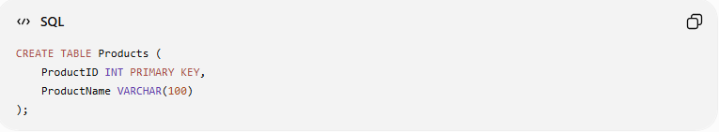
CREATE TABLE Products (
ProductID INT PRIMARY KEY,
ProductName VARCHAR(100)
);

After
Users
Products
A new table has been added.

2️⃣ Add a New Column
# Source: AI Source: Provided by: [Data Path: Persons Table -> ID Column: 1, Name_En Column: Motasem Essam] -> From: [ChatGPT] on [6/7/2026]
Before
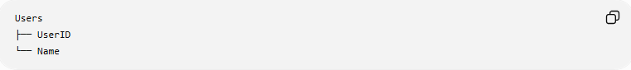
Users
├── UserID
└── Name

Migration
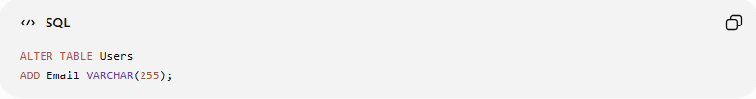
ALTER TABLE Users
ADD Email VARCHAR(255);

After
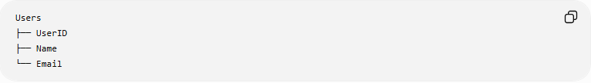
Users
├── UserID
├── Name
└── Email

3️⃣ Remove a Column
# Source: AI Source: Provided by: [Data Path: Persons Table -> ID Column: 1, Name_En Column: Motasem Essam] -> From: [ChatGPT] on [6/7/2026]
Before
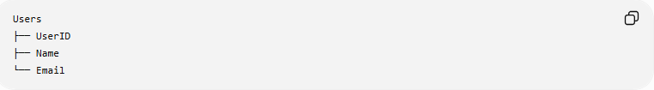
Users
├── UserID
├── Name
└── Email

Migration
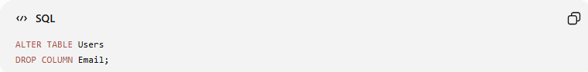
ALTER TABLE Users
DROP COLUMN Email;

After
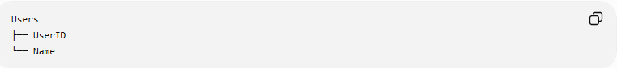
Users
├── UserID
└── Name

4️⃣ Modify a Column
# Source: AI Source: Provided by: [Data Path: Persons Table -> ID Column: 1, Name_En Column: Motasem Essam] -> From: [ChatGPT] on [6/7/2026]
Before
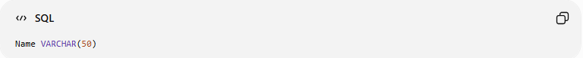
Name VARCHAR(50)

Migration
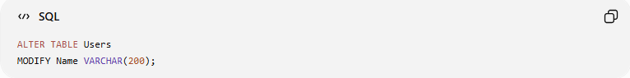
ALTER TABLE Users
MODIFY Name VARCHAR(200);

After
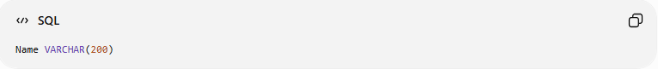
Name VARCHAR(200)
The column can now store longer names.

5️⃣ Rename a Column
# Source: AI Source: Provided by: [Data Path: Persons Table -> ID Column: 1, Name_En Column: Motasem Essam] -> From: [ChatGPT] on [6/7/2026]
Before
Name

Migration
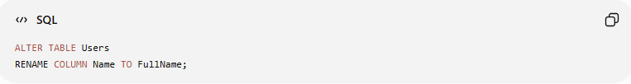
ALTER TABLE Users
RENAME COLUMN Name TO FullName;

After
FullName

6️⃣ Add Constraints
# Source: AI Source: Provided by: [Data Path: Persons Table -> ID Column: 1, Name_En Column: Motasem Essam] -> From: [ChatGPT] on [6/7/2026]
Before
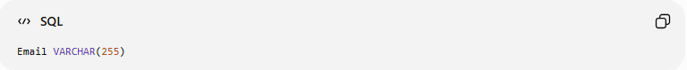
Email VARCHAR(255)

Migration
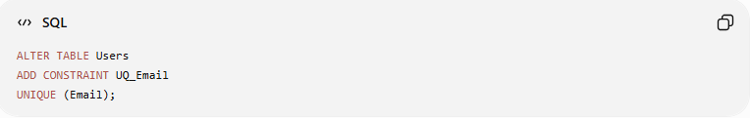
ALTER TABLE Users
ADD CONSTRAINT UQ_Email
UNIQUE (Email);

After
Email must be unique

7️⃣ Create an Index
# Source: AI Source: Provided by: [Data Path: Persons Table -> ID Column: 1, Name_En Column: Motasem Essam] -> From: [ChatGPT] on [6/7/2026]
Migration
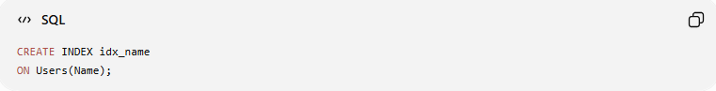
CREATE INDEX idx_name
ON Users(Name);

Purpose:
Faster Searches

🛠️ Real-World Example
# Source: AI Source: Provided by: [Data Path: Persons Table -> ID Column: 1, Name_En Column: Motasem Essam] -> From: [ChatGPT] on [6/7/2026]
Version 1
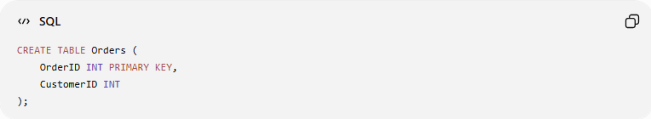
CREATE TABLE Orders (
OrderID INT PRIMARY KEY,
CustomerID INT
);

Application grows and needs order tracking.

Schema Migration
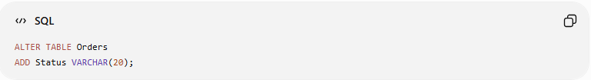
ALTER TABLE Orders
ADD Status VARCHAR(20);

Version 2
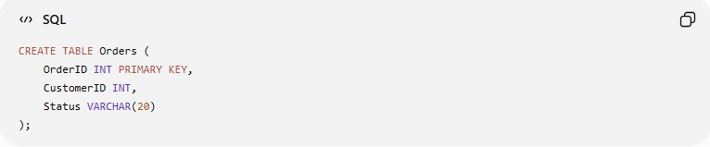
CREATE TABLE Orders (
OrderID INT PRIMARY KEY,
CustomerID INT,
Status VARCHAR(20)
);

Now orders can store:
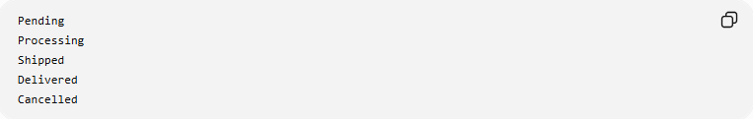
Pending
Processing
Shipped
Delivered
Cancelled

🔄 Schema Migration Lifecycle
# Source: AI Source: Provided by: [Data Path: Persons Table -> ID Column: 1, Name_En Column: Motasem Essam] -> From: [ChatGPT] on [6/7/2026]
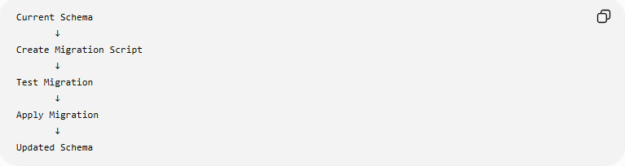
Current Schema
↓
Create Migration Script
↓
Test Migration
↓
Apply Migration
↓
Updated Schema

📦 Example Migration Script
# Source: AI Source: Provided by: [Data Path: Persons Table -> ID Column: 1, Name_En Column: Motasem Essam] -> From: [ChatGPT] on [6/7/2026]
Migration File
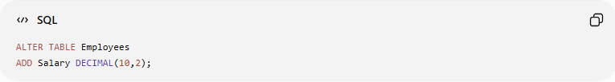
ALTER TABLE Employees
ADD Salary DECIMAL(10,2);

Result
Before:
EmployeeID
Name
After:
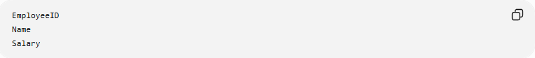
EmployeeID
Name
Salary

↩️ Rollback Example
# Source: AI Source: Provided by: [Data Path: Persons Table -> ID Column: 1, Name_En Column: Motasem Essam] -> From: [ChatGPT] on [6/7/2026]
Migration
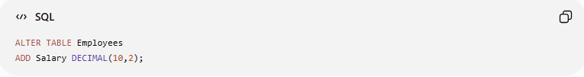
ALTER TABLE Employees
ADD Salary DECIMAL(10,2);

Rollback
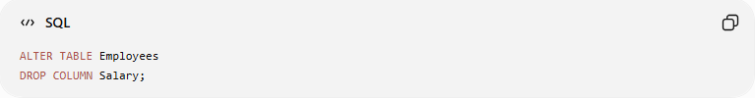
ALTER TABLE Employees
DROP COLUMN Salary;

Process:
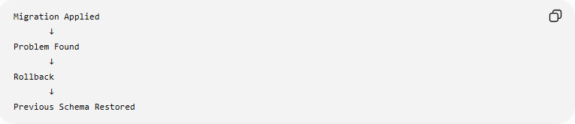
Migration Applied
↓
Problem Found
↓
Rollback
↓
Previous Schema Restored

📊 Schema Migration vs Data Migration
# Source: AI Source: Provided by: [Data Path: Persons Table -> ID Column: 1, Name_En Column: Motasem Essam] -> From: [ChatGPT] on [6/7/2026]
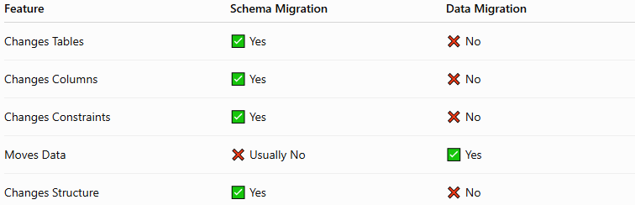
Feature | Schema Migration | Data Migration
Changes Tables | ✅ Yes | ❌ No
Changes Columns | ✅ Yes | ❌ No
Changes Constraints | ✅ Yes | ❌ No
Moves Data | ❌ Usually No | ✅ Yes
Changes Structure | ✅ Yes | ❌ No

Example
Schema Migration
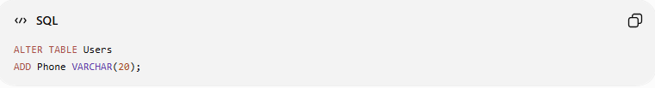
ALTER TABLE Users
ADD Phone VARCHAR(20);
Changes structure.

Data Migration
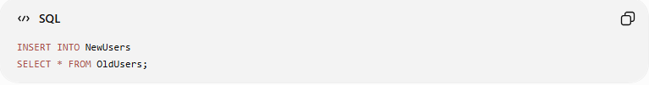
INSERT INTO NewUsers
SELECT * FROM OldUsers;
Moves data.

⚠️ Risks of Schema Migration
# Source: AI Source: Provided by: [Data Path: Persons Table -> ID Column: 1, Name_En Column: Motasem Essam] -> From: [ChatGPT] on [6/7/2026]
Possible problems:
- Application failures
- Lost columns
- Broken relationships
- Slow database performance
- Downtime

✅ Best Practices
# Source: AI Source: Provided by: [Data Path: Persons Table -> ID Column: 1, Name_En Column: Motasem Essam] -> From: [ChatGPT] on [6/7/2026]
Backup Before Migration
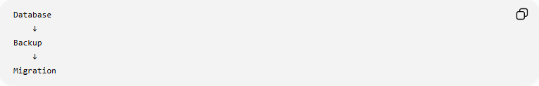
Database
↓
Backup
↓
Migration

Test First
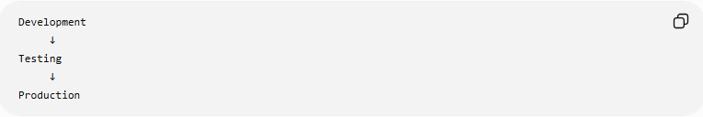
Development
↓
Testing
↓
Production

Version Control Migrations
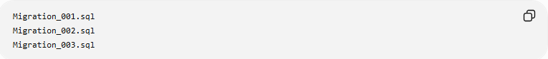
Migration_001.sql
Migration_002.sql
Migration_003.sql

Prepare Rollbacks
Always create:
Migration Script
Rollback Script

🛠️ Popular Schema Migration Tools
# Source: AI Source: Provided by: [Data Path: Persons Table -> ID Column: 1, Name_En Column: Motasem Essam] -> From: [ChatGPT] on [6/7/2026]
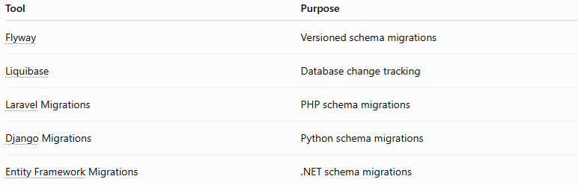
Tool | Purpose
Flyway | Versioned schema migrations
Liquibase | Database change tracking
Laravel Migrations | PHP schema migrations
Django Migrations | Python schema migrations
Entity Framework Migrations | .NET schema migrations

🧠 Simple Analogy
# Source: AI Source: Provided by: [Data Path: Persons Table -> ID Column: 1, Name_En Column: Motasem Essam] -> From: [ChatGPT] on [6/7/2026]
Think of a house blueprint.
Before
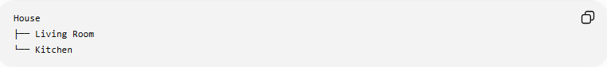
House
├── Living Room
└── Kitchen

Renovation
Add Bedroom

After
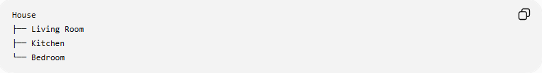
House
├── Living Room
├── Kitchen
└── Bedroom
The structure changed, but you didn't move the furniture.
That is similar to Schema Migration:
Change Structure
Not Data

🧭 Summary
# Source: AI Source: Provided by: [Data Path: Persons Table -> ID Column: 1, Name_En Column: Motasem Essam] -> From: [ChatGPT] on [6/7/2026]
Schema Migration is a type of database migration that changes the structure of a database. Common operations include creating tables, adding or removing columns, modifying data types, adding constraints, renaming objects, and creating indexes. Schema migrations help databases evolve alongside applications while maintaining organization, performance, and data integrity.

